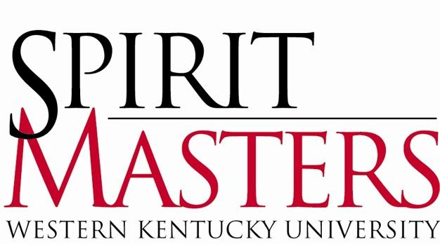

2026-2027 Spirit Master Application

Spirit Masters are the official student ambassadors of Western Kentucky University. The title “Spirit Masters” is derived from the university motto, “The Spirit Makes the Master.” Our purpose is to provide an extra measure of hospitality at WKU, making visitors feel they have had a truly exceptional experience. Spirit Masters work closely with those interested in promoting WKU, including the Office of the President, the Office of Admissions, Philanthropy and Alumni Engagement, WKU Athletics, and various community groups.

If you are interested in applying to become a Spirit Master, please take note of the following dates and deadlines:

November 5, 2025 Spirit Master ‘Meet & Greet’
Wednesday 7:00 p.m. - 8:30 p.m.
Downing Student Union, 2124

February 11, 2026 Spirit Master ‘Meet & Greet’
Wednesday 7:00 p.m. - 8:30 p.m.
Downing Student Union, 3020

March 4, 2026 Spirit Master Application Deadline
Wednesday Email packet to spirit.masters@wku.edu by 11:59 p.m.

March 13, 2026 Post schedule for 1st round interviews
Friday Wetherby Administration, Front Entrance

March 23-25, 2026 First-Round Interviews
Monday – Wednesday 5:30 p.m. – 9:00 p.m.
Cherry Hall

March 27, 2026 Post schedule for 2nd round interviews
Friday Wetherby Administration, Front Entrance

March 30-April 1, 2026 Second-Round Interviews
Monday – Wednesday 5:00 p.m. – 9:00 p.m.
Cliff Todd Center

April 1, 2026 Spirit Masters, Class of 2026-2027
Wednesday ‘Meet Me on the Hill’
Midnight, Cherry Hall

April 18-19, 2026 Spirit Master Training Retreat
Saturday-Sunday Overnight

April 29, 2026 Spirit Master Banquet
Wednesday 6:00 p.m.
Eva and Jim Martens Alumni Center

ABOUT THE SELECTION PROCESS

The selection of new Spirit Masters occurs in three parts:

- Timely submission of a completed application with references, class schedule, unofficial academic transcript, and photo.
- First-round interview for all applicants with a panel consisting of three to four members of the University faculty, staff, and administration.
- Second-round interview for selected applicants with the Spirit Masters Advisory Council and additional appointed individuals.

New Spirit Masters are selected based on their performance in all levels of the selection process.

MEMBERSHIP CRITERIA

- Maintain a cumulative GPA of 2.5 or higher.
- Hold an enrollment classification of least a second-semester freshman.
- Maintain full-time enrollment as an undergraduate student for the subsequent academic year.
- Must be a fully enrolled undergraduate student at Western Kentucky University who is not concurrently enrolled in any dual-credit or early-college residential program.
- If selected as a new Spirit Master in the spring of 2026, you must be present for the following fall semester. After your first full semester as a new Spirit Master, you may participate in the WKU Study Abroad or Study Away.
- Devote at least sixty (60) hours in the fall semester and forty (40) hours in the spring semester to assignment obligations; however, the expectation is that Spirit Masters go “Above the Rim.”
- Attend the mandatory Spirit Masters Training Retreat; April 18 – 19, 2026.
- Attend weekly Spirit Master meetings, currently scheduled for Wednesdays at 9:00pm.
- Desire to learn all facets of WKU and remain updated on current events and progressive changes concerning the University community.
- Hold a willingness to learn the Office of Admissions’ WKU Campus Tour, both shuttle and walking, and to present it in a professional manner to prospective students, their parents, and campus visitors.
- Possess excellent oral communication skills and poise while interacting with diverse groups.

SPIRIT MASTER APPLICATION PACKET

Please submit the entire application packet as one “.pdf” document by March 4, 2026. The Spirit Master Application must contain the following:
- Personal Information
- Short Answer Questions (Typed Document)
- Recent Color Photo
- Current Spring 2026 Class Schedule from TopNet
- Unofficial Academic Transcript from TopNet
- Two Reference Letters
PERSONAL INFORMATION

Full Name: ________________________________________________________
Preferred Name: ___________________________________________________
Pronouns: ________________________________________________________
WKU ID: __________________________________________________________
Email: ____________________________________________________________
Cell Phone: ________________________________________________________

Local Address (WKU Address): Permanent Address (Parent/Guardian):
_____________________________ _________________________________
_____________________________ _________________________________
_____________________________ _________________________________

School Classification: ___________________ Years Remaining at WKU: ____________
Completed Credit Hours: ________________
Cumulative GPA: _______________________
Major(s): _____________________________ Minors(s): __________________
Have you applied to Spirit Masters before? __________
Place of Employment: _________________________________________________________
Hours Per Week: _____________________________________________________________
Are there dates or times that you would be unavailable for a first-round interview? _______
If so, when? _________________________________________________________________
If participating in Study Abroad or Study Away during the interview process, please specify the exact location and program (i.e. Harlaxton, Australia, New York, etc.): ___________________________________________________________________________

SHORT ANSWER QUESTIONS
Please answer the following questions. Limit your responses to a maximum 500 words per question. Be sure to number each answer with the correct question number.

- List ALL campus activities, organizations, and outside interests (hobbies, volunteer work, etc.) with which you are currently involved. Briefly mention any office(s) currently held and/or past positions held. If you are a freshman, include any positions held in high school.
- What would you consider to be the most important attribute for one to possess in serving as an official representative of WKU? Why?
- Suppose that a high school senior is applying to various colleges and is interested in WKU. Aside from size and diversity, what would you consider one advantage of WKU? Additionally, what is one disadvantage?
- What do you expect to give and receive from involvement in Spirit Masters?
- What does “The Spirit Makes the Master” mean to you?

LETTERS OF REFERENCE

Letters of Reference must be submitted using the reference form found on the Spirit Master Website. References can be individuals from WKU but can also be anyone the applicant feels could best speak to your character and abilities, regardless of their connection to WKU. Letters must be submitted to spirit.masters@wku.edu in addition to the application packet.

WKU Faculty/Staff or Community Reference
Name: Department/Organization: Office Phone:

WKU Student or Peer Reference
Name:
Classification:
Phone:

If you have any questions regarding the selection process, please contact:
Landry Steenbergen, Spirit Master Chair Cai Coburn, Spirit Master Vice-Chair
landry.steenbergen406@topper.wku.edu spirit.masters@wku.edu

Please use additional pages to answer the short answer questions and attach your photo, class schedule, and unofficial class transcript.

