presents

***Recital Name***

featuring

Performer, *Instrument/Voice Part*

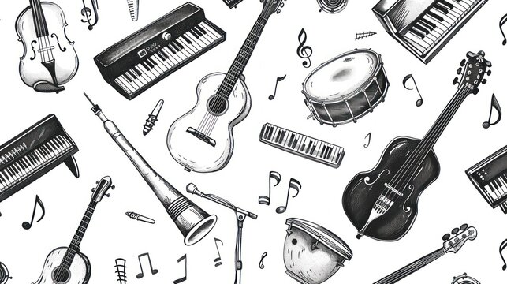

Long Date & Time (ex: Monday, March 31st, 2025 at 7:30 PM)

Location (ex: Fine Arts Center Recital Hall)

**Program**

*(EXAMPLE)* Vier Lieder Alma Mahler

1. Licht in der Nacht (1879 – 1964)
2. Waldseligkeit
3. Ansturm
4. Erntelied

Piece Title Composer

1. Movement I (Yrs living)
2. Movement II
3. Movement III

Accompanist Name, *Instrument*

Piece Title Composer

1. Movement I (Yrs living)
2. Movement II
3. Movement III

Accompanist Name, *Instrument*

Piece Title Composer

1. Movement I (Yrs living)
2. Movement II
3. Movement III

Accompanist Name, *Instrument*

**Program (or program notes if applicable)**

**Upcoming Events/Acknowledgements**