How to position a point centered to the front parcel boundary (i.e., the front property line) with a defined distance inward or offset (see figure below).

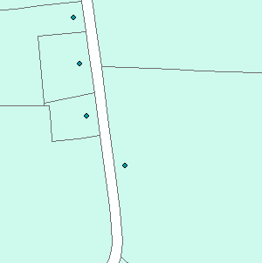
Fig. 1. Points centered to “front” of property with a 50’ offset.

Below are the following steps to accomplish this task. The steps begin with parcels as polygons. (Note: The “front” of the parcel can be identified as that portion of the parcel that is adjacent to a street. This isn’t true in all cases, because of street adjacent to more than one side like corner lots or streets front and back of the property.

- Select the polygon that represents the space occupied by roads, i.e., the white space in figure 1 separating parcels. (If the parcel dataset excludes this polygon, then create it.) Export this “road polygon” as its own feature class (or shapefile). Next, create a buffer (side type is FULL and end type is ROUND) to the distance in which the points are to be offset from the “front” of the parcel boundary.

- Next is to run the intersect tool (ArcToolbox | Analysis Tools | Overlay | Intersect) with the input features as the parcel polygon feature class and buffer feature class created in step 1. This will create a line feature class as shown below (in red), which is important for the next step in converting lines to points and extracting points.

(a) (b) (c)
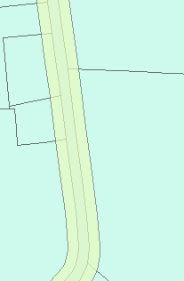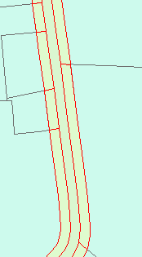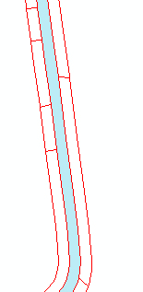
Fig. 2. (a) Buffer around roads. The resultant (b) of running the
intersect tool and (c) displayed without the parcel polygon feature
class.
- Convert the intersect line feature class to points (ArcToolbox | Data Management Tools | Features | Feature to Point) and be sure that the “Inside (optional)” is checked. By checking “Inside,” this assures that the point will be created on the line, which will be important for extraction later. Points created are ideally position to the center of that line. (Note: Line features created from the intersect tool have line features cracked at points of intersection.)

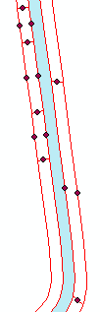
Fig. 3. Feature to point.

- Convert the buffer polygon feature, which was created earlier around the roads polygon, to a line feature so that points can be selected by spatial location that are on the “perimeter” of the buffer. This allows the points that are “centered to the front parcel boundary with an offset” to be selected.

(a) (b)
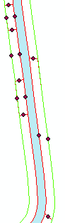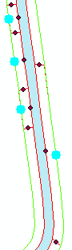
Fig. 4. (a) Before and (b) after selecting points by spatial location
(i.e., “I want to: select features from the following layer(s): Line
_to_Points that: intersect the features in this layer: Line_Buffer.)

- Export selected points to a feature class or shapefile.

(a) (b)
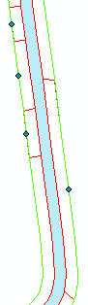
Fig. 5. The final product (a) without parcels and (b) with parcels.
After running step 5, it is advised to spot check the points because of the following constraints: (1) parcels that are completely surrounded by a road, (2) parcels that have a road adjacent to both its front and back, (3) parcels that are completely within the buffer, (4) and parcels not included because of access roads or easements (refer back to the first note). Although spot checking is advised, most of the work is completed! It’s easier to delete or move a few points than it is to create and move points for all of the parcels.

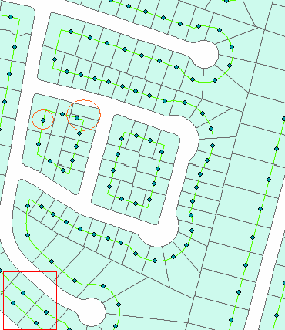
Fig. 6. Parcels with a point “centered” to the front of its property
line with an offset of 50 feet. Take note to the lower left-hand
corner to the front and back road phenomenon and area enclosed by orange circles mentioned earlier in the above passage.

Notes compiled by:
Kevin B. Cary, M.Sc., GISP
GIS Director, Geography & GIS Instructor
Center for GIS at WKU
Dept. of Geography & Geology
Ogden College of Science & Engineering
Western Kentucky University
1906 College Heights Blvd 31066
Bowling Green, KY 42101-1066

http://www.wku.edu/gis

