Assurance of Student Learning Report
2023-2024
NOTE: Outcomes 1, 2, 3 (SLO 1, 2, and 3) are reassessments from baseline measures taken in AY22-23;
Outcomes 4 and 5 (SLO 9 and 10) are baseline measures taken this year.
PCAL |  | English
067
Dr. Trini Stickle
Is this an online program? Yes No | Please make sure the Program Learning Outcomes listed match those in CourseLeaf . Indicate verification here Yes, they match! (If they don’t match, explain on this page under Assessment Cycle)
*** Please include Curriculum Map as part of this document (at the end), NOT as a separate file.
Use this page to list learning outcomes, measurements, and summarize results for your program. Detailed information must be completed in the subsequent pages. Add more Outcomes as needed.
Program Student Learning Outcome 1: SLO 1: The student can describe the terminology, methodology, and practices of literary criticism.
Instrument 1 | Direct: A random sample of final paper from the SP24 graduate literature course ENG 468G, ENG 497G, and ENG 597.
Based on your results, check whether the program met the goal Student Learning Outcome 1. |  | Met | Not Met
Program Student Learning Outcome 2: SLO 2: The student can evaluate the cultural and intellectual significance of individual works for literature.
Instrument 1 | Direct: A random sample of final paper from the SP24 graduate literature course ENG 468G, ENG 497G, and ENG 597.
Based on your results, check whether the program met the goal Student Learning Outcome 2. |  | Met | Not Met
Program Student Learning Outcome 3: SLO 3: The student can apply the terminology, methodology, and practices of literary criticism to contribute to ongoing scholarly conversations in literary studies.
Instrument 1 | Direct: A random sample of final paper from the SP24 graduate literature course ENG 468G, ENG 497G, and ENG 597.
Based on your results, check whether the program met the goal Student Learning Outcome 3. |  | Met | Not Met
Assessment Cycle Plan:
In AY22-23, we developed a five-year assessment plan (see below). The plan is designed to 1) assess and reassess all the SLOs within a five year period; 2) select a manageable number of random assessment artifacts that captured our graduate students across the two-year program; 3) initially obtain a baseline assessment; 4) continue with a reassessment schedule for a five-year protocol to better ensure we address deficits and to have sufficient data for the MA program review each 5 years. The tentative five-year assessment plan is as follows:
MA Assessment AY22-23—YR 1 (A&2223)
Courses: Literature—final paper (n=9)
Baseline score for SLO 1, 2, 3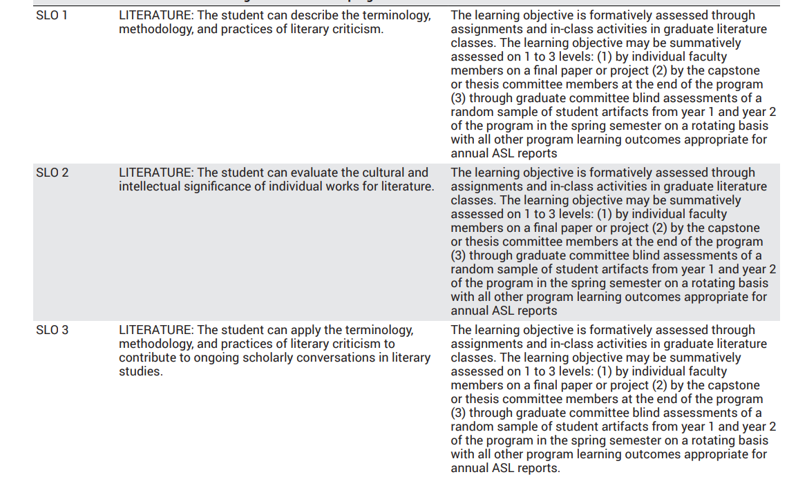

MA Assessment AY23-24—YR 2 (AY23-24)
Course: ENG 520 (n = 10-12)
Baseline score for SLO 9 and 10
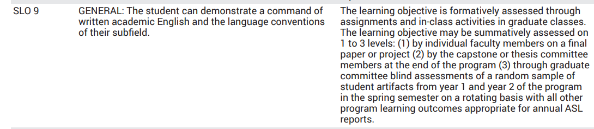

Reassess SLOs 1, 2, 3.

MA Assessment AY24-25—YR 3 (AY24-25)
Courses: Comp Rhet/PW (n = 8-14)
Baseline score for SLOs 5 and 6
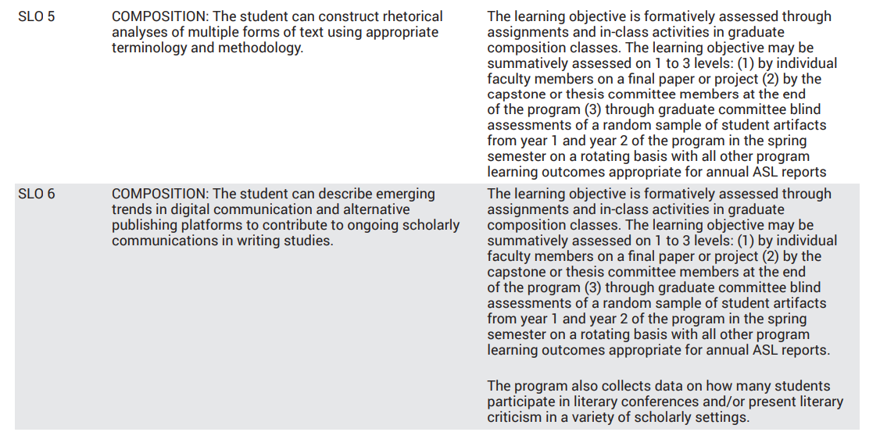
Recheck SLO 1, 2, and/or 3 if insufficient results from year 1
Select a random sampling (20%) of literature papers from this year’s courses.
Data will be used for MA program assessment occurring this year.

MA Assessment AY25-26—YR 4 (AY25-26)
Course: Linguistic, pedagogy, and/or theory (n = 8-15)
Baseline score for SLO 7, 8, 9
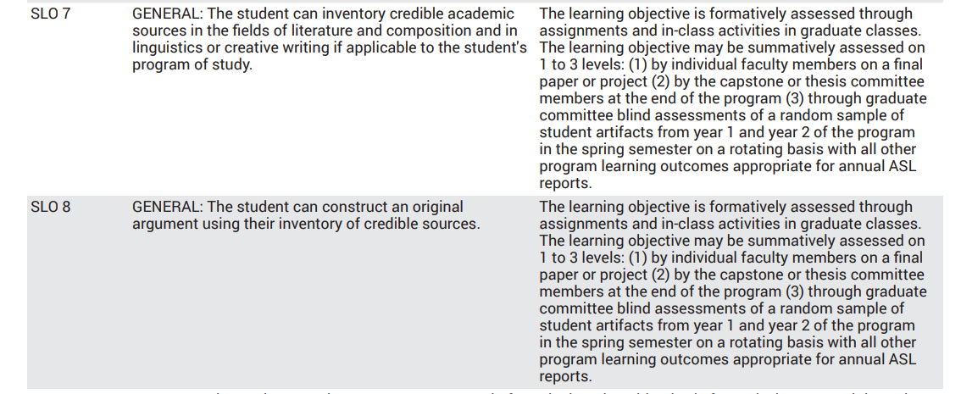
Recheck SLOs 9 with this year’s selection of papers.

MA Assessment AY26-27—YR 5 (AY26-27)
Courses: A random selection (20%) of Comp/Rhet or PW courses
Recheck SLOs 5 and 6

Course: 520
Recheck SLO 10

Data will be stored for the next MA program assessment. After year 5, the graduate committee should review the SLO assessment sequence and process for suggested improvements and changes to the curriculum, SLOs, assessment artifacts, and other program areas as deemed by this comprehensive review.
.

Program Student Learning Outcome 1

Program Student Learning Outcome | SLO 1: The student can describe the terminology, methodology, and practices of literary criticism.
Measurement Instrument 1 | Direct: A random sample of final paper from the SP24 graduate literature course ENG 468G, ENG 497G, and ENG 597.  With the revised MA program available in catalog AY23-24, our plan for the next five years is to establish a benchmark rating for all 10 of the SLOs, address deficits, and redress those deficits with course development plans. We also plan to evaluate/re-evaluate each SLO within the five-year assessment cycle.  The first assessment for SLO 1, 2, and 3 (description of the three SLOs are located in the rubric below) was completed in AY23-24. The AY23-24 is a reassessment of these SLOs.  The literature courses are designed to develop students’ literary analyses skills toward a professional level. The three courses chosen represent the scope of literature—time periods, genres, themes—and these three courses are a sampling of our literature instructors. The papers also represent students at various stages within the two-year program (see the import of this selection in result section).  The rubric used to measure this and each SLO is shown below and can also be found at this link:  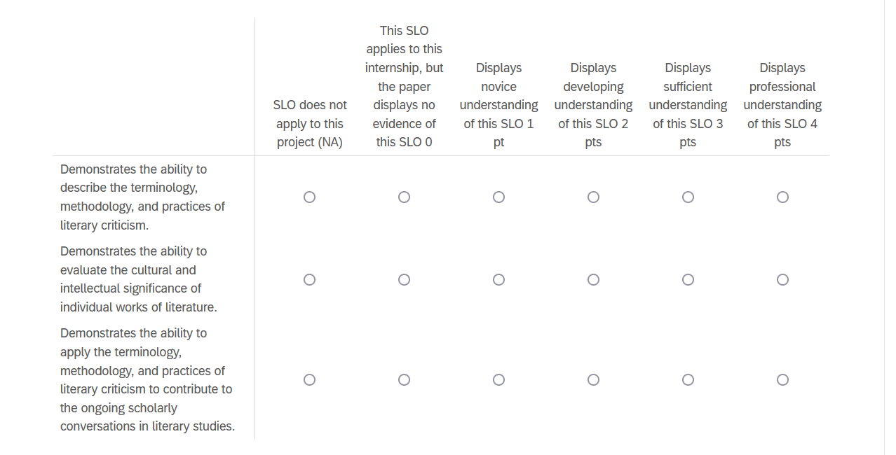
Criteria for Student Success | Criteria for student success is a score of 3 or higher across all three literature SLOs or an overall average of a score of 3 or higher on the 4 point scale listed above, across all three SLOs.
Program Success Target for this Measurement |  | Target success is 70% of students meet this measure. Since students may take literature courses any semester across the two-year program, this percentage accounts for students who are still developing these skills. | Percent of Program Achieving Target | 80% or 8 of the 10 students met our success threshold for the individual measure for SLO 1.  This is an improvement from last year’s baseline assessment in which only 22% or 2 of the 9 student papers from AY22-23 received a 3 or higher.
Methods | SP24 Literature courses were identified. All three of the literature courses were included in the assessment. Additionally, the random sampling of literature papers (selected by the program coordinator) assured that only one paper per graduate student was assessed in this cycle, that is, if a graduate student attended and completed course papers for more than one literature course, only one paper of that student was selected for the assessment process. The selection was random—that is, the papers were not read before the selection. This selection process yielded 10 MA student papers from a total population of 11 MA students, for a sampling of 90.9% of MA graduate students.  The ten papers were anonymized and posted for assessment (see rubric above). Four independent raters—the English department’s three graduate committee faculty members and the program coordinator—scored each paper according to the rubric above.  The average scores for each SLO per student were calculated as well as a composite score for all three SLOs combined.
Based on your results, highlight whether the program met the goal Student Learning Outcome 1. |  |  |  | Met | Not Met
Results, Conclusion, and Plans for Next Assessment Cycle (Describe what worked, what didn’t, and plan going forward)
See below under SLO 3.

Program Student Learning Outcome 2
Program Student Learning Outcome | SLO 2: The student can evaluate the cultural and intellectual significance of individual works for literature.
Measurement Instrument 1 | Direct: A random sample of final paper from the SP24 graduate literature course ENG 468G, ENG 497G, and ENG 597.
Criteria for Student Success | Criteria for student success is a score of 3 or higher across all three literature SLOs or an overall average of a score of 3 or higher on the 4 point scale listed above, across all three SLOs.
Program Success Target for this Measurement |  |  | Target success is 70% of students meet this measure. Since students may take literature courses any semester across the two-year program, this percentage accounts for students who are still developing these skills. |  | Percent of Program Achieving Target | Results for this SLO decreased significanty as compared to the AY22-23 baseline assessment(a rationale is provided in the Results/Outcome/Plan section below SLO 3). Only 1 of the 10, 10%, of the AY23-24 student papers assessed were found to adequately cover SLO2. This is in contrast to AY22-23 finding in which 44% or 4 of the 9 students met our success threshold for the individual measure for SLO 2.
Methods | SP24 Literature courses were identified. All three of the literature courses were included in the assessment. Additionally, the random sampling of literature papers (selected by the program coordinator) assured that only one paper per graduate student was assessed, that is, if a graduate student attended and completed course papers for more than one literature course, only one paper of that student was selected for the assessment process. The selection was random—that is, the papers were not read before the selection. This selection process yielded 10 MA student papers from a total population of 11 MA students, for a sampling of 90.9% of MA graduate students.  The ten papers were anonymized and posted for assessment (see rubric above). Four independent raters—the English department’s three graduate committee faculty members and the program coordinator—scored each paper according to the rubric above.  The average scores for each SLO per student were calculated as well as a composite score for all three SLOs combined.
Based on your results, circle or highlight whether the program met the goal Student Learning Outcome 2. |  |  |  |  |  | Met | Not Met
Results, Conclusion, and Plans for Next Assessment Cycle (Describe what worked, what didn’t, and plan going forward)
See below under SLO 3.

Program Student Learning Outcome 3
Program Student Learning Outcome | SLO 3: The student can apply the terminology, methodology, and practices of literary criticism to contribute to ongoing scholarly conversations in literary studies.
Measurement Instrument 1 | Direct: A random sample of final paper from the SP24 graduate literature course ENG 468G, ENG 497G, and ENG 597.
Criteria for Student Success | Criteria for student success is a score of 3 or higher across all three literature SLOs or an overall average of a score of 3 or higher on the 4 point scale listed above, across all three SLOs.
Program Success Target for this Measurement |  |  | Target success is 70% of students meet this measure. Since students may take literature courses any semester across the two-year program, this percentage accounts for students who are still developing these skills. |  | Percent of Program Achieving Target | 80% or 8 of the 10 students met our success threshold for the individual measure for SLO 3.  This is an improvement from last year’s baseline assessment in which only 11% or 1 of the 9 student papers from AY22-23 received a 3 or higher.
Methods | SP24 Literature courses were identified. All three of the literature courses were included in the assessment. Additionally, the random sampling of literature papers (selected by the program coordinator) assured that only one paper per graduate student was assessed, that is, if a graduate student attended and completed course papers for more than one literature course, only one paper of that student was selected for the assessment process. The selection was random—that is, the papers were not read before the selection. This selection process yielded 10 MA student papers from a total population of 11 MA students, for a sampling of 90.9% of MA graduate students.  The ten papers were anonymized and posted for assessment (see rubric above). Four independent raters—the English department’s three graduate committee faculty members and the program coordinator—scored each paper according to the rubric above.  The average scores for each SLO per student were calculated as well as a composite score for all three SLOs combined.
Based on your results, circle or highlight whether the program met the goal Student Learning Outcome 3. |  |  |  |  |  | Met | Not Met
Results, Conclusion, and Plans for Next Assessment Cycle (Describe what worked, what didn’t, and plan going forward)
Results: Our reassessment of SLO 1, 2, and 3 resulted in SLO 1 and 3 showing great improvements from our baseline assessment of AY22-23 for the individual assessment scores.
Acceptable student performance on SLO 1 increased from 22% to 80%; for SLO 3, 11% to 80%.
Acceptable student performance of SLO 2, however, decreased from 44% to 10%.

An acceptable aggregate score of 3 or higher across all three literature SLOs for individual papers, however, was achieved reaching the required 70% , 7 of the 10 papers.

Of the10 students, 8 are students in their first year of the program—7 in their 2nd semester of 4 semesters and 1 is in his first semester; 2 are in their final year of the program.

Conclusions: Both SLO 1 and SLO 3 center on the understanding and employment of literary methods, terms, and theories, and as such, should be part of any graduate literary analysis. The improvement in student performance between AY22-23 and AY23-24 for SLO 1 and SLO 3 is, we believe, the result of active conversations in our department with faculty. Last year, we identified the need to provide an extensive introduction to the practices of literary analysis at the graduate level, and our faculty responded, we believe, by doing so as evidenced by the present results.

The lower demonstration of SLO 2—the evaluation of the cultural and intellectual significance of a given work--in this year’s sampling may be due to the types of literature courses from which the papers were culled. In AY22-23, the theme of culture within two of the literature courses has a distinct priority (immigrant literature and working class litersture). The focus of and works chosen for this year’s courses along with the themes and motifs explored may not have easily facilitated avenues of analyses for culture or as easily as did the year before (AY23-24 courses were on fantastic literature, Shakespeare, and women’s literature); still, a piece of literature is always situated within the culture designed within the work and within the culture that creates it, so evidence of cultural significance of some type seems expected. Likewise, a discussion of a works’ intellectual significance within a graduate literary analysis is expected. We find the inclusion of such topics to be a conversation worth having with our literature instructors: if not a focus of a graduate paper but perhaps expected in the introductory or discussion sections of all papers.

Plans for Next Assessment Cycle: With our recent instantiation a new 5-year assessment plan in tandem with a more rigorous assessment process, we will be 1) closely examining these first benchmark SLO assessments within the MA program and 2) adjusting content of so that each SLO is both addressed and assessed in multiple areas of the program. Following from our first year’s plan, we will continue to hold conversations with our faculty on how best to direct our students as they develop their professional literary (and other) skills within each course and how we can better instruct and design assignments that allow for such development. We will continue our conversations with faculty through subdisciplinary focal groups as we improve our MA program to better meet the needs of our students and program goals.

Use this page to list learning outcomes, measurements, and summarize results for your program. Detailed information must be completed in the subsequent pages. Add more Outcomes as needed.
Program Student Learning Outcome 4: SLO 9: The student can demonstrate a command of written academic English and the language conventions of their subfield.
Instrument 1 | Final papers from FA24 ENG 520, Introduction to Graduate Studies
Based on your results, check whether the program met the goal Student Learning Outcome 4. |  | Met | Not Met
Program Student Learning Outcome 5: SLO 10: The student can describe a 5-year plan for continuing education/professional development appropriate to the English profession.
Instrument 1 | Final papers from FA24 ENG 520, Introduction to Graduate Studies
Based on your results, check whether the program met the goal Student Learning Outcome 5. |  | Met | Not Met

Program Student Learning Outcome 4

Program Student Learning Outcome | SLO 9: The student can demonstrate a command of written academic English and the language conventions of their subfield.
Measurement Instrument 1 | Since all MA graduate students are required to take the ENG 520 Introduction to Graduate Studies course, and since this course is designed to prepare students to pursue and better develop their MA study with a professional plan, we selected the two exit artifacts from this course to evaluate students command of written academic English (the professional book review) and their plan for this degree (the final reflection essay). Because we were not able to offer the ENG 520 course during AY22-23, this selection process yielded both first and second year MAs, with all 11 MA students present, for a sampling of 100% of MA students.  The 11 papers were anonymized and posted for assessment. Four independent raters—the English department’s three graduate committee faculty members and the program coordinator—scored each paper according to the rubric above.  The average scores for each SLO per student were calculated.  The Qualtrics survey link provided the papers to assess along with 5-choice assessment (image below).  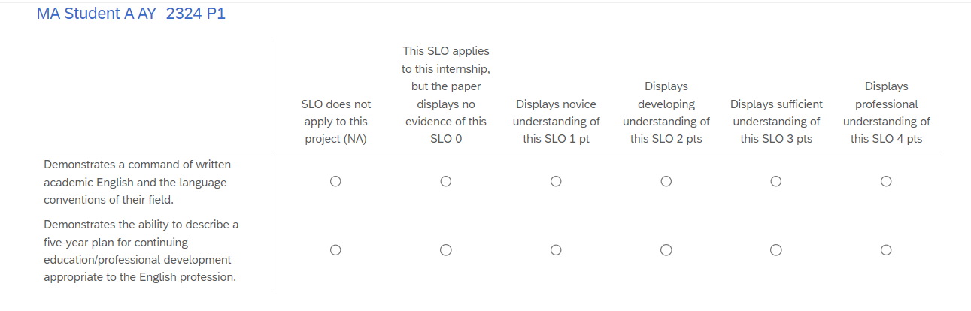
Criteria for Student Success | Criteria for student success is a minimum score of 3 out of a 4 point scale.
Program Success Target for this Measurement |  |  | Target success is 80% of students meet this measure. Command of the English language is central to the success and employment of this master’s degree. Still, this measure is taken during a first semester course and we expect some students, particularly non-native English speaking graduate students, will develop their accuracy of and sophistication with the English language. |  | Percent of Program Achieving Target | 63.6%, or 7 of the 11 student papers, demonstrated command of written academic English.
Methods | Since all MA graduate students are required to take the ENG 520 Introduction to Graduate Studies course, and since this course is designed to prepare students to pursue and better develop their MA study with a professional plan, we selected the two exit artifacts from this course to evaluate students command of written academic English (the professional book review) and their plan for this degree (the final reflection essay). Because we were not able to offer the ENG 520 course during AY22-23, this selection process yielded both first and second year MAs, with all 11 MA students present, for a sampling of 100% of MA students.  The 11 papers were anonymized and posted for assessment. Four independent raters—the English department’s three graduate committee faculty members and the program coordinator—scored each paper according to the rubric above.  The average scores for each SLO per student were calculated.  The Qualtrics survey link provided the papers to assess along with 5-choice assessment (image below).
Based on your results, highlight whether the program met the goal Student Learning Outcome 1. |  |  |  |  |  | Met |  | Not Met
Results, Conclusion, and Plans for Next Assessment Cycle (Describe what worked, what didn’t, and plan going forward)
Results: Are the results what was expected or not? What stood out in the assessment cycle? Explain

Conclusions: What worked? What didn’t? Why do you thinks this? For example, maybe the content in one or more courses was modified; changed course sequence (detail modifications); changed admission criteria (detail modifications); changed instructional methodology (detail modifications); changed student advisement process (detail modifications); program suspended; changed textbooks; facility changed (e.g. classroom modifications); introduced new technology (e.g. smart classrooms, computer facilities, etc.); faculty hired to fill a particular content need; faculty instructional training; development of a more refined assessment tool.

**IMPORTANT - Plans for Next Assessment Cycle: As we work hard to improve our assessment practices and make them more meaningful and effective, it’s important each program craft a plan for the following year’s assessment – this process assists in “closing the loop.” For example, you may decide to collect a more appropriate artifact. Or, you may need to adjust targets because there are cionsistently exceeded or not met; Or, you might see the need to reconstruct your curriculum map. Or, you’ve found that the sequencing of classes might need to be adjusted, or additional class(es) provided. Whatever you plan is, provide a narrative, in future tense, that indicates how you will approach future assessments. All changes need not lead to quantitative results.

Program Student Learning Outcome 5
Program Student Learning Outcome | SLO 10: The student can describe a 5-year plan for continuing education/professional development appropriate to the English profession.
Measurement Instrument 1 | Final papers from FA24 ENG 520, Introduction to Graduate Studies
Criteria for Student Success | A minimum score of 3 out of a 4 point scale.
Program Success Target for this Measurement |  |  | Target success is 70% of students meet this measure. Since students usually take the Introduction to Grad Studies their first year, it is our goal that upon completion they can and have mapped out a five year plan for their degree, we accept that many will not have a clear pathway at this stage. |  | Percent of Program Achieving Target |  | 27% or 3 of the 11 student papers demonstrated in their reflection exit paper a plan for the skills they expected to acquire during their degree.
Methods | Since all MA graduate students are required to take the ENG 520 Introduction to Graduate Studies course, and since this course is designed to prepare students to pursue and better develop their degree with a professional plan, we selected the final reflection essay as a means to evaluate the students' five-year plan for this degree. Because we were not able to offer the ENG 520 course during AY22-23, this selection process yielded both first and second year MAs, with all 11 MA students present, for a sampling of 100% of MA students.  The 11 papers were anonymized and posted for assessment. Four independent raters—the English department’s three graduate committee faculty members and the program coordinator—scored each paper according to the rubric above.  The average scores for each SLO per student were calculated.  The Qualtrics survey link provided the papers to assess along with 5-choice assessment (see link and image provided with the Outcome 4 Methods).
Based on your results, circle or highlight whether the program met the goal Student Learning Outcome 2. |  |  |  |  |  |  | Met |  | Not Met
Results, Conclusion, and Plans for Next Assessment Cycle (Describe what worked, what didn’t, and plan going forward)
Results: The assessment results for SLO 9 and 10 are lower than expected. Of the 11 students, 2 were students in their last year of the program, semester 3 of 4; 9 were in their first year, first semester of the program.

For SLO 9, the range of paper scores is 2.00 – 3.50. The mean is 3.10. The median and mode are both 3.00.

The 2 graduating students in their 3rd semester of 4) each of their papers received a 3.00—meeting the benchmark. Of the first year, first semester students, 5 are meeting the benchmark score of a 3 or higher. 4 first year, first semester students require improvement.

The range of paper scores for SLO10 is 1.00-3.50. The mean is 1.97. The median is 1.75. The mode is both 1 and 1.75.

Conclusions: While our overall program goals were not met in either SLO 9 or 10, the assessment gives incredible data on our student population and for curriculum and coursework revision. For SLO 9—command of the English language—the data show that our students, while within an English master’s degree program, require some explicit instruction on facility with structure and conventions. In part, we usually have one to two non-native speakers in the program as well as one or two students who did not major in English during their undergraduate degrees. Since most of our graduate students are native English speaking students who come from an English background, this data suggests we add into our curriculum a short course on advanced structure/convention/lexical development.

For SLO 10, on developing a five-year plan, the data show simply enough that the instruction for the reflection piece needs to address each student’s individual five-year plan for their degree. If students are expecting this final assignment, as they learn about the program, the course choices, and develop their professional approaches to literature and writing during ENG 520, then we expect future assessments for SLO 10 will show our students’ mastery of this goal.

Plans for Next Assessment Cycle: With our recent instantiation a new 5-year assessment plan in tandem with a more rigorous assessment process, we will be 1) closely examining these first benchmark SLO assessments within the MA program and 2) adjusting content of so that each SLO is both addressed and assessed in multiple areas of the program.
To that end, we will adding several short segments on grammar/conventions/professional lexical development into our ENG 520; and we will advise the lead instructors of ENG 520 to explicity discuss the development of a five-year plan throughout the course in preparation for the final reflection assignment.

Curriculum Map is posted at the end of this document.

Curriculum Map
