Assurance of Student Learning Report
2023-2024
Ogden College of Science and Engineering |  | School of Engineering and Applied Sciences
Electrical Engineering program, #537
Assessment coordinator: Stacy Wilson
Is this an online program? Yes No | Please make sure the Program Learning Outcomes listed match those in CourseLeaf . Indicate verification here Yes, they match! (If they don’t match, explain on this page under Assessment Cycle)

Use this page to list learning outcomes, measurements, and summarize results for your program. Detailed information must be completed in the subsequent pages.
Student Learning Outcome 1: ABET EAC Outcome #1: Upon graduation our students have the ability to identify, formulate, and solve complex engineering problems by applying principles of engineering, science, and mathematics.
Instrument 1 | Artifacts assessed in certain courses/sections
Instrument 2 | Senior Exit Surveys
Based on your results, check whether the program met the goal Student Learning Outcome 1. |  | Met | Not Met
Student Learning Outcome 2: ABET EAC Outcome #2: Upon graduation, our students have the ability to apply engineering design to produce solutions that meet specified needs with consideration of public health, safety, and welfare, as well as global, cultural, social, environmental, and economic factors.
Instrument 1 | Artifacts assessed in certain courses/sections
Instrument 2 | Senior Exit Surveys
Based on your results, check whether the program met the goal Student Learning Outcome 2. |  | Met | Not Met
Student Learning Outcome 3: ABET EAC Outcome #3: Upon graduation, our students have the ability to communicate effectively with a range of audiences.
Instrument 1 | Artifacts assessed in certain courses/sections
Instrument 2 | Senior Exit Surveys
Based on your results, check whether the program met the goal Student Learning Outcome 3. |  | Met | Not Met
Student Learning Outcome 4: ABET EAC Outcome #4: Upon graduation, our students have the ability to recognize ethical and professional responsibilities in engineering situations and make informed judgments, which must consider the impact of engineering solutions in global, economic, environmental, and societal contexts.
Instrument 1 | Artifacts assessed in certain courses/sections
Instrument 2 | Senior Exit Surveys
Based on your results, check whether the program met the goal Student Learning Outcome 3. |  | Met | Not Met
Student Learning Outcome 5: ABET EAC Outcome #5: Upon graduation, our students have the ability to function effectively on a team whose members together provide leadership, create a collaborative and inclusive environment, establish goals, plan tasks, and meet objectives.
Instrument 1 | Artifacts assessed in certain courses/sections
Instrument 2 | Senior Exit Surveys
Based on your results, check whether the program met the goal Student Learning Outcome 3. |  | Met | Not Met
Student Learning Outcome 6: ABET EAC Outcome #6: Upon graduation, our students have the ability to develop and conduct appropriate experimentation, analyze and interpret data, and use engineering judgment to draw conclusions.
Instrument 1 | Artifacts assessed in certain courses/sections
Instrument 2 | Senior Exit Surveys
Based on your results, check whether the program met the goal Student Learning Outcome 3. |  | Met | Not Met

Student Learning Outcome 7: ABET EAC Outcome #7: Upon graduation, our students have the ability to acquire and apply new knowledge as needed, using appropriate learning strategies.
Instrument 1 | Artifacts assessed in certain courses/sections
Instrument 2 | Senior Exit Surveys
Based on your results, check whether the program met the goal Student Learning Outcome 3. |  | Met | Not Met
Program Summary (Briefly summarize the action and follow up items from your detailed responses on subsequent pages.)
All Student Learning Outcomes were met.

The EE program discussed the rubric results on May 9, 2024 from the past academic year. Action items are described below.

Student Learning Outcome 1
Student Learning Outcome | ABET EAC Outcome #1: Upon graduation our students have the ability to identify, formulate, and solve complex engineering problems by applying principles of engineering, science, and mathematics.
Measurement Instrument 1 | Artifacts were assessed in some or all sections of the following courses: EE 300, EE 420, EE 431, EE 460, ENGR 490 and ENGR 491.
Criteria for Student Success | The following rubric is used when assessing student performance:  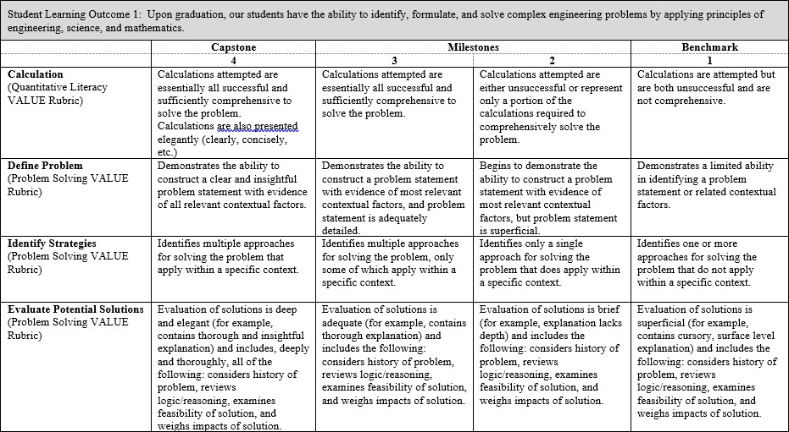  We look for a minimum average of 2.50 for each assessed junior-level course section, and 3.00 for each assessed senior-level course section. Of the courses assessed for this Outcome, EE 300, 420 and 473 are considered junior-level, with the remaining courses considered senior-level.

Program Success Target for this Measurement |  |  | Target weighted averages are 2.50 for assessed junior-level course sections combined, and 3.00 for assessed senior-level course sections combined. |  | Percent of Program Achieving Target Weighted Averages for  course sections  assessed: | 3.26
Methods | Instructors choose artifacts to assess, using the above rubric, in their respective courses/sections. These artifacts will be different course section-to-course section, instructor-to-instructor, and semester-to-semester. Each item of the rubric (e.g., calculation, define problem, etc.) was weighted equally when scoring the rubric. In some cases, specific items may not have been scored.  We looked at the average obtained for each course section assessed, with each of the junior-level course sections targeted to achieve a minimum average of 2.50, and each of the senior-level course sections targeted to achieve a minimum average of 3.00. It was observed that all assessed course sections met their target.  We also calculated two weighted rubric averages for this Outcome this academic year: one for all assessed junior-level course sections and one for all assessed senior-level course sections. This was done to determine if, overall, the Outcome was met. The minimum weighted averages were expected to be 2.50 and 3.00, respectively. This was our Program Success Target. As indicated above, we achieved averages of 3.88 and 3.31.
Measurement Instrument 2 | Senior Exit Surveys are typically given to students taking the senior design course during the fall and spring semesters. However this academic year, the survey was only administered in the spring semester due to the Fall 2022 ABET visit. Students were asked to “Rate your ability to identify, formulate, and solve complex engineering problems by applying principles of engineering, science, and mathematics” on a scale of 1 to 5 (with 5 being the highest).
Criteria for Student Success | Average score on this item is above 3.75.
Program Success Target for this Measurement |  | Target average of 3.75 |  | Percent of Program Achieving Target Weighted Average: |  | 4.16
Methods | For this year there were 12 responses for Fall 2023 and 7 responses for Spring 2024. The weighted average is the average of all the responses received on this particular item.
Based on your results, highlight whether the program met the goal Student Learning Outcome 1. |  |  |  |  |  | Met | Not Met
Actions (Describe the decision-making process and actions for program improvement. The actions should include a timeline.)
Through the assessment of work in various courses, it has been noted that students have insufficient program skills. To correct this deficiency, the program faculty are changing the curriculum to require more programming (CS 180 instead of CS 239) and to add more CS programming courses to the list of electrical engineering elective options. Starting in Fall 2024, all incoming EE students will also be required to take a second programming course (CS 290).
Follow-Up (Provide your timeline for follow-up. If follow-up has occurred, describe how the actions above have resulted in program improvement.)
The program faculty will review the assessment results at the end of every spring semester.

Next Assessment Cycle Plan (Please describe your assessment plan timetable for this outcome)
The EE program assesses courses in support of learning outcomes every semester. At the end of the next several academic years, the program faculty will continue the assessment plan to determine the effectiveness of this change. It will take some time to see the results.

Student Learning Outcome 2
Student Learning Outcome | ABET EAC Outcome #2: Upon graduation, our students have the ability to apply engineering design to produce solutions that meet specified needs with consideration of public health, safety, and welfare, as well as global, cultural, social, environmental, and economic factors.
Measurement Instrument 1 | Artifacts were assessed in some or all sections of the following courses: ENGR 490, ENGR 491
Criteria for Student Success | The following rubric is used when assessing student performance:  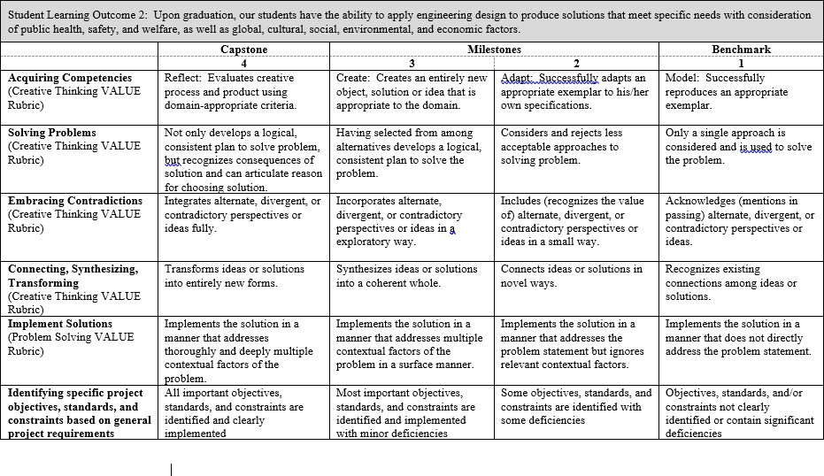  We look for a minimum average of 2.50 for each assessed junior-level course section, and 3.00 for each assessed senior-level course section.
Program Success Target for this Measurement |  | Target weighted averages are 2.50 for assessed junior-level course sections combined, and 3.00 for assessed senior-level course sections combined. | Percent of Program Achieving  Target Weighted Averages for course  sections assessed: | 3.32

Methods | Instructors choose artifacts to assess, using the above rubric, in their respective courses/sections. These artifacts will be different course section-to-course section, instructor-to-instructor, and semester-to-semester. Each item of the rubric (e.g., acquiring competencies, solving problems, etc.) was weighted equally when scoring the rubric. In some cases, specific items may not have been scored.  We looked at the average obtained for each course section assessed, with each of the junior-level course sections targeted to achieve a minimum average of 2.50, and each of the senior-level course sections targeted to achieve a minimum average of 3.00. It was observed that most assessed course sections met their targets.  We also calculated two weighted rubric averages for this Outcome this academic year: one for all assessed junior-level course sections and one for all assessed senior-level course sections. This was done to determine if, overall, the Outcome was met. The minimum weighted averages were expected to be 2.50 and 3.00, respectively. This was our Program Success Target. As indicated above, we achieved averages of 3.43 in senior level courses. No junior level courses were assessed this year in support of this Outcome.
Measurement Instrument 2 | Senior Exit Surveys are typically given to students taking the senior design course during the fall and spring semesters. However this academic year, the survey was only administered in the spring semester due to the Fall 2022 ABET visit. Students were asked to “Rate your ability to apply engineering design to produce solutions that meet specific needs with consideration for public health, safety, and welfare, as well as global, cultural, social, environmental, and economic factors” on a scale of 1 to 5 (with 5 being the highest).
Criteria for Student Success | Average score on this item is above 3.75.
Program Success Target for this Measurement |  | Target average of 3.75 | Percent of Program Achieving  Target Weighted Average: | 4.43
Methods | For this year there were 12 responses for Fall 2023 and 7 responses for Spring 2024. The weighted average is the average of all the responses received on this particular item.
Based on your results, circle or highlight whether the program met the goal Student Learning Outcome 2. |  |  |  | Met | Not Met
Actions (Describe the decision-making process and actions planned for program improvement. The actions should include a timeline.)
The EE program discussed the rubric results on May 9, 2024 from the past academic year. We did not see a need to address the rubric scores for this particular Outcome.

Follow-Up (Provide your timeline for follow-up. If follow-up has occurred, describe how the actions above have resulted in program improvement.)
The program faculty will review the assessment results at the end of every spring semester.

Next Assessment Cycle Plan (Please describe your assessment plan timetable for this outcome)
The EE program assesses courses in support of learning outcomes every semester.

Student Learning Outcome 3
Student Learning Outcome | ABET EAC Outcome #3: Upon graduation, our students have the ability to communicate effectively with a range of audiences.
Measurement Instrument 1 | Artifacts were assessed in some or all sections of the following courses: EE 300, EE 380, ENGR 490, ENGR 491
Criteria for Student Success | The following rubrics are used when assessing student performance (NOTE: only written communication was assessed in EE 460):  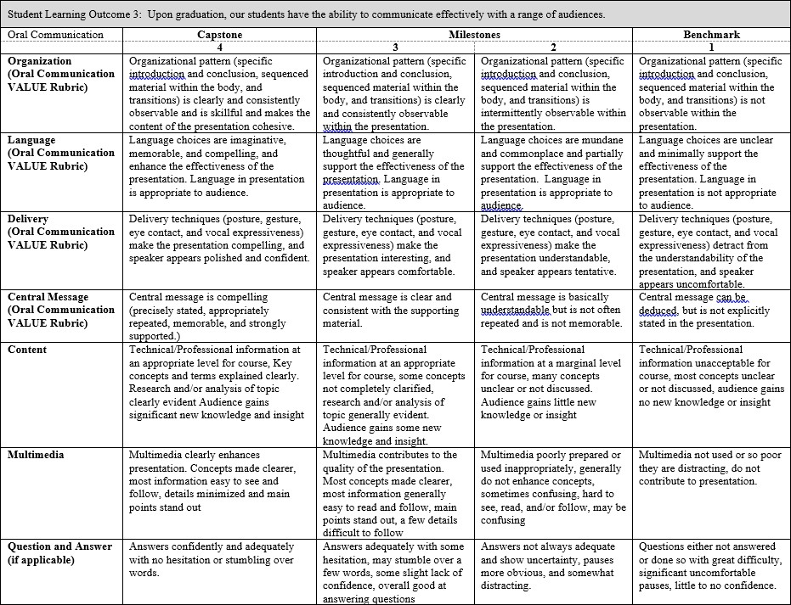

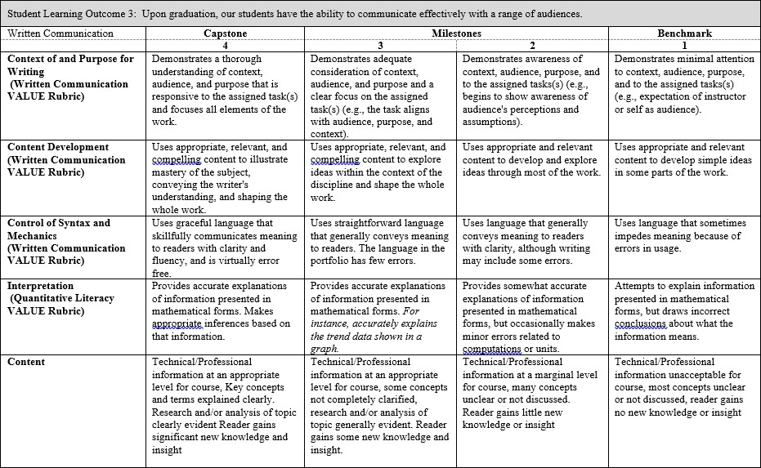

We look for a minimum average of 2.50 for each assessed junior-level course section, and 3.00 for each assessed senior-level course section. Of the courses assessed for this Outcome, EE 300 and EE 380 are considered junior-level, with the remaining courses considered senior-level.
Program Success Target for this Measurement |  | Target weighted averages are 2.50 for assessed junior-level course sections combined, and 3.00 for assessed senior- level course sections combined. | Percent of Program Achieving Target Weighted Averages for course sections assessed: | Assessment of oral communication: 3.42  Assessment of written communication: 3.36
Methods | Instructors choose artifacts to assess, using the above rubrics, in their respective courses/sections. These artifacts will be different course section-to-course section, instructor-to-instructor, and semester-to-semester. Each item of the rubrics (e.g., organization, language, etc.) was weighted equally when scoring the rubric. In some cases, specific items may not have been scored.

We looked at the average obtained for each course section assessed, with each of the junior-level course sections targeted to achieve a minimum average of 2.50, and each of the senior-level course sections targeted to achieve a minimum average of 3.00. It was observed that most assessed course sections met their targets.

We also calculated two sets of weighted rubric averages for this Outcome this academic year: one set for all assessed junior-level course sections and one set for all assessed senior-level course sections. This was done to determine if, overall, the Outcome was met. The minimum weighted averages were expected to be 2.50 and 3.00, respectively. This was our Program Success Target. As indicated above, we achieved averages of 3.94/3.58 (oral/written) and 3.69/3.70 (oral/written).
Measurement Instrument 2 | Senior Exit Surveys are typically given to students taking the senior design course during the fall and spring semesters. However this academic year, the survey was only administered in the spring semester due to the Fall 2022 ABET visit. Students were asked to “Rate your ability to communicate effectively with range of audiences” on a scale of 1 to 5 (with 5 being the highest).
Criteria for Student Success | Average score on this item is above 3.75.
Program Success Target for this Measurement |  | Target average of 3.75 | Percent of Program Achieving  Target Weighted Average: | 3.78
Methods | For this year there were 12 responses for Fall 2023 and 7 responses for Spring 2024. The weighted average is the average of all the responses received on this particular item.
Based on your results, circle or highlight whether the program met the goal Student Learning Outcome 3. |  |  |  | Met | Not Met
Actions (Describe the decision-making process and actions for program improvement. The actions should include a timeline.)
The EE program discussed the rubric results on May 9, 2024 from the past academic year. We did not see a need to address the rubric scores for this particular Outcome.

Follow-Up (Provide your timeline for follow-up. If follow-up has occurred, describe how the actions above have resulted in program improvement.)
The program faculty will review the assessment results at the end of every spring semester.
Next Assessment Cycle Plan (Please describe your assessment plan timetable for this outcome)
The EE program assesses courses in support of learning outcomes every semester.

Student Learning Outcome 4
Student Learning Outcome | ABET EAC Outcome #4: Upon graduation, our students have the ability to recognize ethical and professional responsibilities in engineering situations and make informed judgments, which must consider the impact of engineering solutions in global, economic, environmental, and societal contexts.
Measurement Instrument 1 | Artifacts were assessed in some or all sections of the following courses: EE 300, ENGR 490, ENGR 491
Criteria for Student Success | The following rubric is used when assessing student performance:  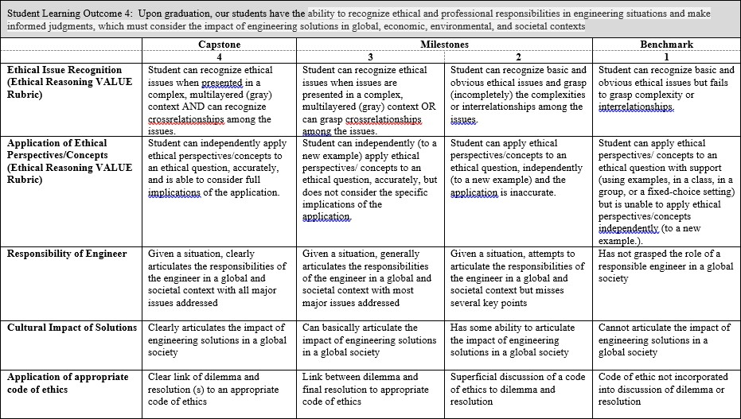  We look for a minimum average of 2.50 for each assessed junior-level course section, and 3.00 for each assessed senior-level course section. Of the courses assessed for this Outcome, EE 300 is considered junior-level, with the remaining courses considered senior-level.
Program Success Target for this Measurement |  | Target weighted averages are 2.50 for assessed junior-level course sections combined, and 3.00 for assessed senior- level course sections combined. | Percent of Program Achieving Target Weighted Averages for course sections assessed: | 3.49
Methods | Instructors choose artifacts to assess, using the above rubric, in their respective courses/sections. These artifacts will be different course section-to-course section, instructor-to-instructor, and semester-to-semester. Each item of the rubric (e.g., ethical issue recognition, application of ethical perspectives/concepts, etc.) was weighted equally when scoring the rubric. In some cases, specific items may not have been scored.  We looked at the average obtained for each course section assessed, with each of the junior-level course sections targeted to achieve a minimum average of 2.50, and each of the senior-level course sections targeted to achieve a minimum average of 3.00. It was observed that all assessed course sections met their targets.

 | We also calculated two weighted rubric averages for this Outcome this academic year: one for all assessed junior-level course sections and one for all assessed senior-level course sections. This was done to determine if, overall, the Outcome was met. The minimum weighted averages were expected to be 2.50 and 3.00, respectively. This was our Program Success Target. As indicated above, we achieved averages of 3.84 and 3.58.
Measurement Instrument 2 | Senior Exit Surveys are typically given to students taking the senior design course during the fall and spring semesters. However this academic year, the survey was only administered in the spring semester due to the Fall 2022 ABET visit. Students were asked to “Rate your ability to ability to recognize ethical and professional responsibilities in engineering situations and make informed judgments, which must consider the impact of engineering solutions in global, economic, environmental, and societal contexts” on a scale of 1 to 5 (with 5 being the highest).
Criteria for Student Success | Average score on this item is above 3.75.
Program Success Target for this Measurement |  | Target average of 3.75 | Percent of Program Achieving  Target Weighted Average: | 4.32
Methods | For this year there were 12 responses for Fall 2023 and 7 responses for Spring 2024. The weighted average is the average of all the responses received on this particular item.
Based on your results, circle or highlight whether the program met the goal Student Learning Outcome 3. |  |  |  | Met | Not Met
Actions (Describe the decision-making process and actions for program improvement. The actions should include a timeline.)
The EE program discussed the rubric results on May 9, 2024 from the past academic year. We did not see a need to address the rubric scores for this particular Outcome.

Follow-Up (Provide your timeline for follow-up. If follow-up has occurred, describe how the actions above have resulted in program improvement.)
The program faculty will review the assessment results at the end of every spring semester.

Next Assessment Cycle Plan (Please describe your assessment plan timetable for this outcome)
The EE program assesses courses in support of learning outcomes every semester.

Student Learning Outcome 5
Student Learning Outcome | ABET EAC Outcome #5: Upon graduation, our students have the ability to function effectively on a team whose members together provide leadership, create a collaborative and inclusive environment, establish goals, plan tasks, and meet objectives.
Measurement Instrument 1 | Artifacts were assessed in some or all sections of the following courses: EE 431, ENGR 490, ENGR 491
Criteria for Student Success | The following rubric is used when assessing student performance:  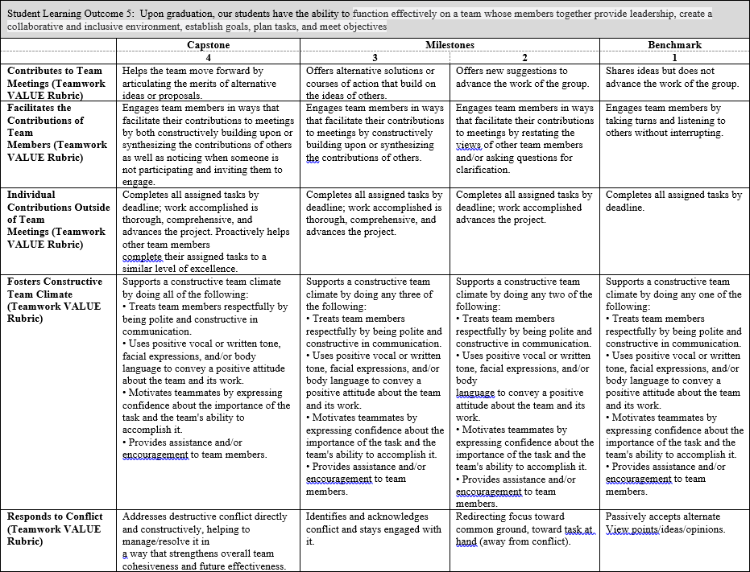  We look for a minimum average of 2.50 for each assessed junior-level course section, and 3.00 for each assessed senior-level course section. Of the courses assessed for this Outcome, EE 300, EE 345 and EE 431 are considered junior-level, with the remaining courses considered senior-level.

Program Success Target for this Measurement |  |  | Target weighted averages are 2.50 for assessed junior-level course sections combined, and 3.00 for assessed senior- level course sections combined. | Percent of Program  Achieving Target Weighted Averages for course sections assessed: |  | 3.43
Methods | Instructors choose artifacts to assess, using the above rubric, in their respective courses/sections. These artifacts will be different course section-to-course section, instructor-to-instructor, and semester-to-semester. Each item of the rubric (e.g., contributes to team meetings, facilitates the contributions of team members, etc.) was weighted equally when scoring the rubric. In some cases, specific items may not have been scored.  We looked at the average obtained for each course section assessed, with each of the junior-level course sections targeted to achieve a minimum average of 2.50, and each of the senior-level course sections targeted to achieve a minimum average of 3.00. It was observed that most assessed course sections met their targets, but one did not.  We also calculated two weighted rubric averages for this Outcome this academic year: one for all assessed junior-level course sections and one for all assessed senior-level course sections. This was done to determine if, overall, the Outcome was met. The minimum weighted averages were expected to be 2.50 and 3.00, respectively. This was our Program Success Target. As indicated above, we achieved averages of 3.35 in senior level courses. No junior level courses were assessed this year in support of this Outcome.
Measurement Instrument 2 | Senior Exit Surveys are typically given to students taking the senior design course during the fall and spring semesters. However this academic year, the survey was only administered in the spring semester due to the Fall 2022 ABET visit. Students were asked to “Rate your ability to function effectively on a team whose members together provide leadership, create a collaborative and inclusive environment, establish goals, plan tasks, and meet objectives” on a scale of 1 to 5 (with 5 being the highest).
Criteria for Student Success | Average score on this item is above 3.75.
Program Success Target for this Measurement |  | Target average of 3.75 |  |  | Percent of Program Achieving  Target Weighted Average: |  | 4.16
Methods | For this year there were 12 responses for Fall 2023 and 7 responses for Spring 2024. The weighted average is the average of all the responses received on this particular item.
Based on your results, circle or highlight whether the program met the goal Student Learning Outcome 3. |  |  |  |  |  |  | Met | Not Met
Actions (Describe the decision-making process and actions for program improvement. The actions should include a timeline.)
The EE program discussed the rubric results on May 9, 2024 from the past academic year. We did not see a need to address the rubric scores for this particular Outcome.

Follow-Up (Provide your timeline for follow-up. If follow-up has occurred, describe how the actions above have resulted in program improvement.)
The program faculty will review the assessment results at the end of every spring semester.

Next Assessment Cycle Plan (Please describe your assessment plan timetable for this outcome)
The EE program assesses courses in support of learning outcomes every semester. At the end of the next several academic years, the program faculty will continue the assessment plan to determine the effectiveness of this change. It will take some time to see the results.

Student Learning Outcome 6
Student Learning Outcome | ABET EAC Outcome #6: Upon graduation, our students have the ability to develop and conduct appropriate experimentation, analyze and interpret data, and use engineering judgment to draw conclusions.
Measurement Instrument 1 | Artifacts were assessed in some or all sections of the following courses: EE 431, EE 460, ENGR 490 and ENGR 491
Criteria for Student Success | The following rubric is used when assessing student performance:  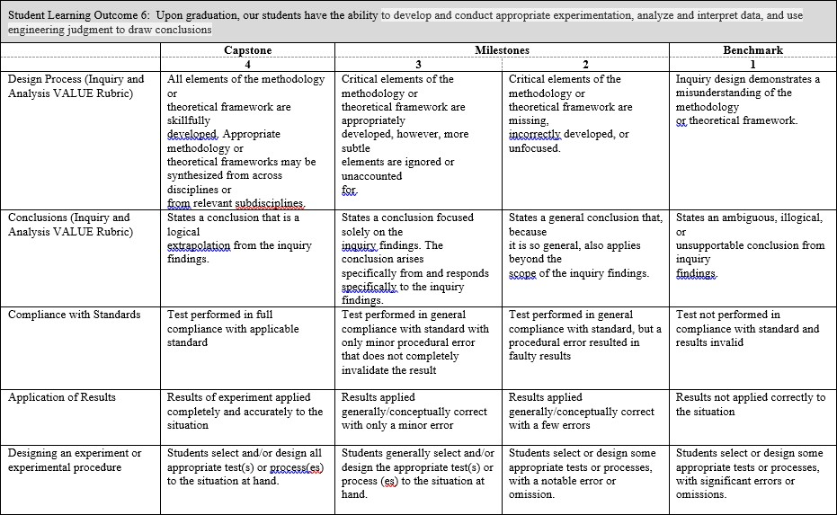  We look for a minimum average of 2.50 for each assessed junior-level course section, and 3.00 for each assessed senior-level course section. Of the courses assessed for this Outcome, EE 345, EE 380 and EE 431 are considered junior-level, with the remaining courses considered senior-level.

Program Success Target for this Measurement |  |  | Target weighted averages are 2.50 for assessed junior-level course sections combined, and 3.00 for assessed senior- level course sections combined. | Percent of Program Achieving Target Weighted Averages for course sections assessed: |  | 3.33
Methods | Instructors choose artifacts to assess, using the above rubric, in their respective courses/sections. These artifacts will be different course section-to-course section, instructor-to-instructor, and semester-to-semester. Each item of the rubric (e.g., design process, conclusions, etc.) was weighted equally when scoring the rubric. In some cases, specific items may not have been scored.  We looked at the average obtained for each course section assessed, with each of the junior-level course sections targeted to achieve a minimum average of 2.50, and each of the senior-level course sections targeted to achieve a minimum average of 3.00. It was observed that most assessed course sections met their targets, but one did not.  We also calculated two weighted rubric averages for this Outcome this academic year: one for all assessed junior-level course sections and one for all assessed senior-level course sections. This was done to determine if, overall, the Outcome was met. The minimum weighted averages were expected to be 2.50 and 3.00, respectively. This was our Program Success Target. As indicated above, we achieved averages of 3.58 in senior level courses. No junior level courses were assessed this year in support of this Outcome.
Measurement Instrument 2 | Senior Exit Surveys are typically given to students taking the senior design course during the fall and spring semesters. However this academic year, the survey was only administered in the spring semester due to the Fall 2022 ABET visit. Students were asked to “Rate your ability to develop and conduct appropriate experimentation, analyze and interpret data, and use engineering judgment to draw conclusions” on a scale of 1 to 5 (with 5 being the highest).
Criteria for Student Success | Average score on this item is above 3.75.
Program Success Target for this Measurement |  | Target average of 3.75 |  |  | Percent of Program Achieving  Target Weighted Average: |  | 4.10
Methods | For this year there were 12 responses for Fall 2023 and 7 responses for Spring 2024. The weighted average is the average of all the responses received on this particular item.
Based on your results, circle or highlight whether the program met the goal Student Learning Outcome 3. |  |  |  |  |  |  | Met | Not Met
Actions (Describe the decision-making process and actions for program improvement. The actions should include a timeline.)
Through the assessment of work in various courses, it has been noted that students have insufficient program skills. To correct this deficiency, the program faculty are changing the curriculum to require more programming (CS 180 instead of CS 239) and to add more CS programming courses to the list of electrical engineering elective options. Starting in Fall 2024, all incoming EE students will also be required to take a second programming course (CS 290).
Follow-Up (Provide your timeline for follow-up. If follow-up has occurred, describe how the actions above have resulted in program improvement.)
The program faculty will review the assessment results at the end of every spring semester.

Next Assessment Cycle Plan (Please describe your assessment plan timetable for this outcome)
The EE program assesses courses in support of learning outcomes every semester. At the end of the next several academic years, the program faculty will continue the assessment plan to determine the effectiveness of this change. It will take some time to see the results.

Student Learning Outcome 7
Student Learning Outcome | ABET EAC Outcome #7: Upon graduation, our students have the ability to acquire and apply new knowledge as needed, using appropriate learning strategies.
Measurement Instrument 1 | Artifacts were assessed in some or all sections of the following courses: ENGR 490, ENGR 491
Criteria for Student Success | The following rubric is used when assessing student performance:  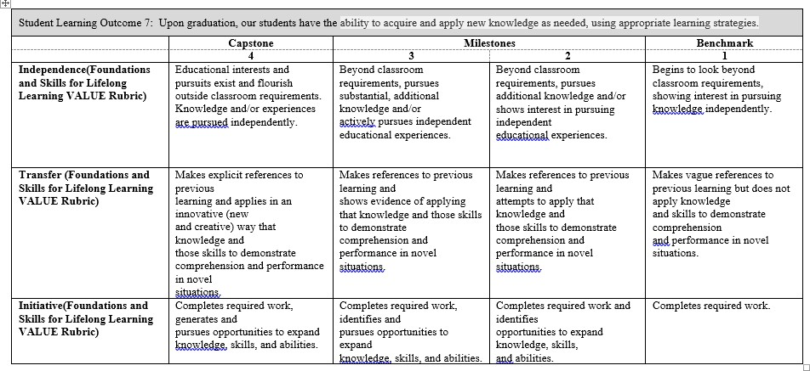  We look for a minimum average of 2.50 for each assessed junior-level course section, and 3.00 for each assessed senior-level course section. Of the courses assessed for this Outcome, EE 300 is considered junior-level, with the remaining courses considered senior-level.
Program Success Target for this Measurement |  | Target weighted averages are 2.50 for assessed junior-level course sections combined, and 3.00 for assessed senior- level course sections combined. | Percent of Program Achieving Target Weighted Averages for course sections assessed: | 3.35

Methods | Instructors choose artifacts to assess, using the above rubric, in their respective courses/sections. These artifacts will be different course section-to-course section, instructor-to-instructor, and semester-to-semester. Each item of the rubric (e.g., independence, transfer, etc.) was weighted equally when scoring the rubric. In some cases, specific items may not have been scored.  We looked at the average obtained for each course section assessed, with each of the junior-level course sections targeted to achieve a minimum average of 2.50, and each of the senior-level course sections targeted to achieve a minimum average of 3.00. It was observed that most assessed course sections met their targets, but one did not.  We also calculated two weighted rubric averages for this Outcome this academic year: one for all assessed junior-level course sections and one for all assessed senior-level course sections. This was done to determine if, overall, the Outcome was met. The minimum weighted averages were expected to be 2.50 and 3.00, respectively. This was our Program Success Target. As indicated above, we achieved averages of 3.45 in senior level courses. No junior level courses were assessed this year in support of this Outcome.
Measurement Instrument 2 | Senior Exit Surveys are typically given to students taking the senior design course during the fall and spring semesters. However this academic year, the survey was only administered in the spring semester due to the Fall 2022 ABET visit. Students were asked to “Rate your ability to acquire and apply new knowledge as needed, using appropriate learning strategies” on a scale of 1 to 5 (with 5 being the highest).
Criteria for Student Success | Average score on this item is above 3.75.
Program Success Target for this Measurement |  | Target average of 3.75 | Percent of Program Achieving  Target Weighted Average: | 4.37
Methods | For this year there were 12 responses for Fall 2023 and 7 responses for Spring 2024. The weighted average is the average of all the responses received on this particular item.
Based on your results, circle or highlight whether the program met the goal Student Learning Outcome 3. |  |  |  | Met | Not Met
Actions (Describe the decision-making process and actions for program improvement. The actions should include a timeline.)
Through the assessment of work in various courses, it has been noted that students have insufficient program skills. To correct this deficiency, the program faculty are changing the curriculum to require more programming (CS 180 instead of CS 239) and to add more CS programming courses to the list of electrical engineering elective options. Starting in Fall 2024, all incoming EE students will also be required to take a second programming course (CS 290).
Follow-Up (Provide your timeline for follow-up. If follow-up has occurred, describe how the actions above have resulted in program improvement.)
The program faculty will review the assessment results at the end of every spring semester.

Next Assessment Cycle Plan (Please describe your assessment plan timetable for this outcome)
The EE program assesses courses in support of learning outcomes every semester. At the end of the next several academic years, the program faculty will continue the assessment plan to determine the effectiveness of this change. It will take some time to see the results.

Relationship of Student Outcomes to Required Courses in the Curriculum

 | Outcome 1 | Outcome 2 | Outcome 3 | Outcome 4 | Outcome 5 | Outcome 6 | Outcome 7
EE 101 | X | X |  | X
EE 180 | X
EE 200 | X | X | X | X | X | X | X
EE 210 | X |  | X |  |  | X | X
EE 211 | X |  | X |  |  | X | X
EE 300 | X | X | X | X | X | X | X
EE 345 | X |  | X |  |  | X | X
EE 380 | X |  | X |  |  | X | X
EE 420 | X
EE 431 | X |  |  |  | X | X
EE 460 | X | X | X
EE 473 | X
ENGR 490 | X | X | X | X | X | X | X
ENGR 491 | X | X | X | X | X | X | X

Relationship of Student Outcomes to Elective Courses in the Curriculum

 | Outcome 1 | Outcome 2 | Outcome 3 | Outcome 4 | Outcome 5 | Outcome 6 | Outcome 7
EE 410 /411 | X | X | X |  | X | X
EE 436 | X | X |  |  |  |  | X
EE 443 | X |  | X |  |  | X | X
EE 445 | X | X |  |  |  |  | X
EE 450/451 | X |  | X |  |  | X
EE 461 | X | X | X
EE 470/475 | X
EE 477 | X
EE 479 | X
EE 480 | X | X | X |  | X
EE 490 | X | X | X |  | X
ENGR 360 | X

