|  |  |  |
| --- | --- | --- |
| **Assurance of Student Learning Report**  **2023-2024** | | |
| *Ogden College of Science and Engineering* | | *School of Engineering and Applied Science* |
| *Construction Management,533* | | |
| *Jason C. Wilson, MS, PE* | | |
| ***Is this an online program***?  Yes  No | Please make sure the Program Learning Outcomes listed match those in CourseLeaf . Indicate verification here  Yes, they match! (If they don’t match, explain on this page under **Assessment Cycle)** | |

**\*\*\* Please include Curriculum Map as part of this document (at the end), NOT as a separate file.**

|  |  |  |  |
| --- | --- | --- | --- |
| ***Use this page to list learning outcomes, measurements, and summarize results for your program. Detailed information must be completed in the subsequent pages. Add more Outcomes as needed.*** | | | |
| **Program Student Learning Outcome 1:**  Ability to create oral presentations appropriate to the construction discipline. | | | |
| **Instrument 1** | **Apply Rubric to Project Reports from selected courses** | | |
| **CM 490** | **Capstone Presentation** | | |
|  |  | | |
| **Based on your results, check whether the program met the goal of Student Learning Outcome 1.** | | **Met** | **Not Met** |
| **Program Student Learning Outcome 2:**  Ability to apply engineering design to produce solutions that meet the specific needs of the surveying industry with consideration of public health, safety, and welfare. | | | |
| **Instrument 1** | **Apply Rubric to Project Reports from selected courses** | | |
| **CM 490** | **Capstone Project** | | |
|  |  | | |
| **Based on your results, check whether the program met the goal of Student Learning Outcome 2.** | | **Met** | **Not Met** |
| **Program Student Learning Outcome 3:**  Ability to acquire and apply new knowledge as needed, using appropriate learning strategies. | | | |
| **Instrument 1** | **Apply Rubric to Project Reports from selected courses** | | |
| **CM 490** | **Capstone Project** | | |
|  |  | | |
| **Based on your results, check whether the program met the goal of Student Learning Outcome 3.** | | **Met** | **Not Met** |
| **Assessment Cycle Plan:** | | | |
| The CM program is pursuing a new accreditation from the American Council for Construction Education (ACCE) and has a new set of SLOs that are not provided in CourseLeaf. Curriculum changes are being evaluated, and new SLOs will be input. | | | |

|  |  |  |  |  |  |
| --- | --- | --- | --- | --- | --- |
| **Student Learning Outcome 1** | | | | | |
| **Student Learning Outcome** | Ability to create oral presentations appropriate to the construction discipline. | | | | |
| **Measurement Instrument 1** | A scoring rubric (attached) specifically structured to assess the attributes stated in the outcome directly is applied to the capstone presentation in CM 490 (Senior Research in Construction Management), which captures key aspects of CM students’ program of study. The rubric assesses 4 main attributes of presentations. The selected courses has, at a minimum, CM 363 as a prerequisite and CM 462 as a corequisite. This course utilizes those specific skills in the development of their capstone project. The CM 490 course is usually taken in the senior year, and students have by then developed a strong understanding of the construction process. | | | | |
| **Criteria for Student Success** | Numerical results from applying the rubric to student work should reach a minimum value of 70% of students achieving a score of 70 or higher. | | | | |
| **Program Success Target for this Measurement** | | 70%/28 or higher | **Percent of Program Achieving Target** | Cohort Average of 77% of students scored a 70 or higher. Average of course was 69% | |
| **Methods** | The final assessment from each student in the course is reviewed separately from course grading. Select questions are identified and the outcome rubric applied to assess achievement. Values from each student are recorded, and a class average is determined. | | | | |
| **Based on your results, highlight whether the program met the goal Student Learning Outcome 1.** | | | | **Met** | **Not Met** |
| **Actions** (Describe the decision-making process and actions for program improvement. The actions should include a timeline.) | | | | | |
| The assessment of student performance under Outcome 1 is acceptable according to rubric-based direct evaluation of student work. At the completion of the course and other relevant courses with satisfactory grades in the curriculum assuring that CM graduates have the ability to create oral presentations appropriate to the construction discipline. The WKU CM program will continue to prepare graduates with the same curriculum content, and monitor this student learning outcome with these measures. No need for programmatic adjustments has been found. | | | | | |
| **Follow-Up** (Provide your timeline for follow-up. If follow-up has occurred, describe how the actions above have resulted in program improvement.) | | | | | |
| None Needed | | | | | |
| **Next Assessment Cycle Plan** (Please describe your assessment plan timetable for this outcome) | | | | | |
| The Construction Management faculty will continue with program assessment on an annual basis. The CM program is in the process of pursuing accreditation by the American Council for Construction Education (ACCE), which requires continual improvement through systematic assessment of student learning outcomes. | | | | | |

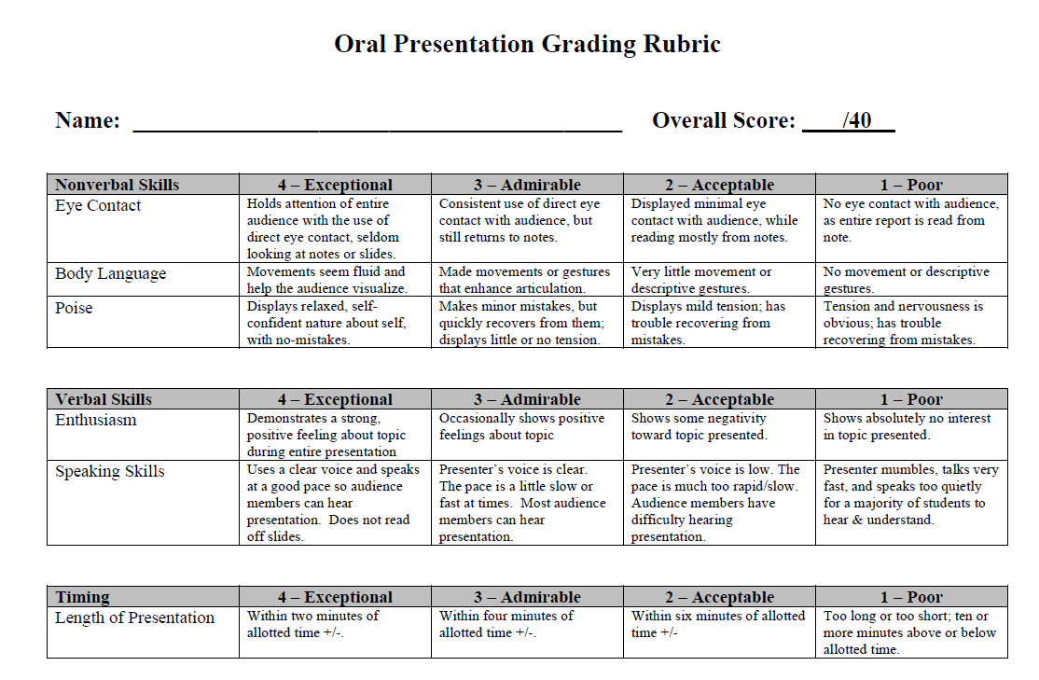

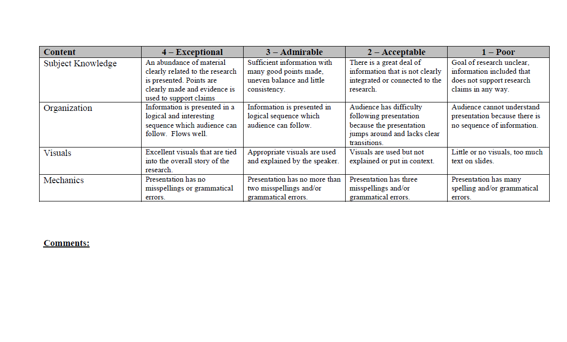

|  |  |  |  |  |  |
| --- | --- | --- | --- | --- | --- |
| **Student Learning Outcome 2** | | | | | |
| **Student Learning Outcome** | Ability to create construction cost estimates. | | | | |
| **Measurement Instrument 1** | A scoring rubric (attached) specifically structured to assess the attributes stated in the outcome directly is applied to the capstone project in CM 490 (Senior Research in Construction Management), which captures key aspects of CM students’ program of study. The rubric assesses 5 main attributes of project cost estimates. The selected courses has, at a minimum, CM 363 as a prerequisite and CM 462 as a corequisite. This course utilizes those specific skills to apply to their capstone project. The CM 490 course is usually taken in the senior year, and students have by then developed a strong understanding of the construction process. | | | | |
| **Criteria for Student Success** | Numerical results from applying the rubric to student work should reach a minimum value of 70% of students achieving a score of 70 or higher. | | | | |
| **Program Success Target for this Measurement** | | 70%/70 or higher | **Percent of Program Achieving Target** | Cohort Average of 65% of students scored a 70 or higher. Average of course was 73% | |
| **Methods** | The final assessment from each team in the course is reviewed separately from course grading. The outcome rubric is applied to assess achievement. Values from each report are recorded, and a class average is determined. This approach captures every student in the assessment year. | | | | |
| **Based on your results, circle or highlight whether the program met the goal Student Learning Outcome 2.** | | | | **Met** | **Not Met** |
| **Actions** (Describe the decision-making process and actions planned for program improvement. The actions should include a timeline.) | | | | | |
| The assessment of student performance under Outcome 2 was not acceptable according to the rubric-based direct evaluation of student work. The WKU CM program will adjust scheduling for the AY 24/25 to require CM 462 – Construction Scheduling to provide a basis of resource allocation and other pertinent information prior to the capstone project course. | | | | | |
| **Follow-Up** (Provide your timeline for follow-up. If follow-up has occurred, describe how the actions above have resulted in program improvement.) | | | | | |
| CM 490 is only offered in the spring semester, there for we will continue to assess annually. Additional assessment checkpoints will be evaluated in other areas of the curriculum. | | | | | |
| **Next Assessment Cycle Plan** (Please describe your assessment plan timetable for this outcome) | | | | | |
| The Construction Management faculty will continue with program assessment on an annual basis. The CM program is pursuing accreditation by the American Council for Construction Education (ACCE), which requires continual improvement through systematic assessment of student learning outcomes. | | | | | |

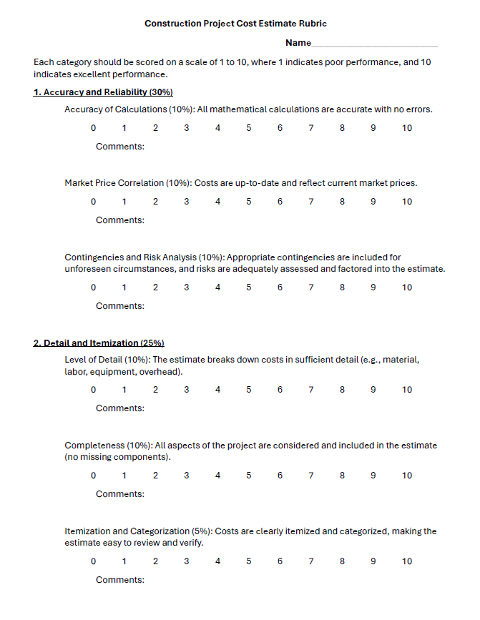

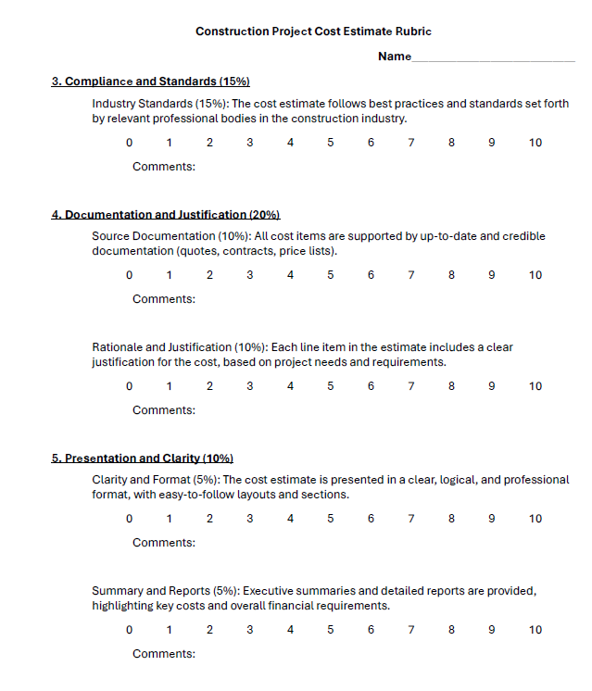

|  |  |  |  |  |  |
| --- | --- | --- | --- | --- | --- |
| **Student Learning Outcome 3** | | | | | |
| **Student Learning Outcome** | Ability to create construction project schedules. | | | | |
| **Measurement Instrument 1** | A scoring rubric (attached) specifically structured to assess the attributes stated in the outcome directly is applied to the capstone project in CM 490 (Senior Research in Construction Management), which captures key aspects of CM students’ program of study. The rubric assesses 3 main attributes of project schedules. The selected course has, at a minimum, CM 363 as a prerequisite and CM 462 as a corequisite. This course utilizes those specific skills to apply to their capstone project. The CM 490 course is usually taken in the senior year, and students have by then developed a strong understanding of the construction process. | | | | |
| **Criteria for Student Success** | Numerical results from applying the rubric to student work should reach a minimum value of 70% of students achieving a score of 70 or higher. | | | | |
| **Program Success Target for this Measurement** | | 70%/70 or higher | **Percent of Program Achieving Target** | A cohort Average of 69% of students scored 70 or higher. The average of course was 70% | |
| **Methods** | The final assessment from each team in the course is reviewed separately from course grading. The outcome rubric is applied to assess achievement. Values from each report are recorded, and a class average is determined. This approach captures every student in the assessment year. | | | | |
| **Based on your results, circle or highlight whether the program met the goal Student Learning Outcome 3.** | | | | **Met** | **Not Met** |
| **Actions** (Describe the decision-making process and actions for program improvement. The actions should include a timeline.) | | | | | |
| The assessment of student performance under Outcome 2 was not acceptable according to the rubric-based direct evaluation of student work. The WKU CM program will adjust scheduling for the AY 24/25 to require CM 462 – Construction Scheduling to provide a basis of resource allocation and other pertinent information before the capstone project course. | | | | | |
| **Follow-Up** (Provide your timeline for follow-up. If follow-up has occurred, describe how the actions above have resulted in program improvement.) | | | | | |
| CM 490 is only offered in the spring semester, so we will continue to assess annually. Additional assessment checkpoints will be evaluated in other areas of the curriculum. | | | | | |
| **Next Assessment Cycle Plan** (Please describe your assessment plan timetable for this outcome) | | | | | |
| The Construction Management faculty will continue with program assessment on an annual basis. The CM program is pursuing accreditation by the American Council for Construction Education (ACCE), which requires continual improvement through systematic assessment of student learning outcomes. | | | | | |

**Curriculum Map**

|  |  |  |  |
| --- | --- | --- | --- |
| **COURSE** | **SLO 1** | **SLO 2** | **SLO 3** |
| **CM 490** | **X** | **X** | **X** |

